Student: Brian Johnston

Class: COP2362

Assignment 5-1

Screenshot

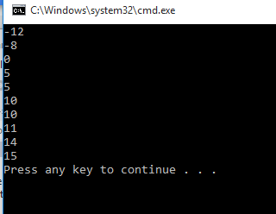

Code:

using System;

using System.Collections.Generic;

using System.Linq;

using System.Text;

using System.Threading.Tasks;

using BinaryTree;

namespace EnumeratorTest

{

class Program

{

static void Main(string[] args)

{

//Create and populate a binary tree of integers

Tree<int> tree1 = new Tree<int>(10);

tree1.Insert(5);

tree1.Insert(11);

tree1.Insert(5);

tree1.Insert(-12);

tree1.Insert(15);

tree1.Insert(0);

tree1.Insert(14);

tree1.Insert(-8);

tree1.Insert(10);

foreach (int item in tree1)

{

Console.WriteLine(item);

}

}

}

}

using System;

using System.Collections.Generic;

using System.Linq;

using System.Text;

namespace BinaryTree

{

public class Tree<TItem> : IEnumerable<TItem> where TItem : IComparable<TItem>

{

public TItem NodeData { get; set; }

public Tree<TItem> LeftTree { get; set; }

public Tree<TItem> RightTree { get; set; }

public Tree(TItem nodeValue)

{

this.NodeData = nodeValue;

this.LeftTree = null;

this.RightTree = null;

}

public void Insert(TItem newItem)

{

TItem currentNodeValue = this.NodeData;

if (currentNodeValue.CompareTo(newItem) > 0)

{